📘 SUPER NOTES (Lecture 1: Java Basics)

Every Java program runs inside a class.
Execution always starts from main().
👉 Think:
- Class = container
- main() = entry gate

Start
↓
JVM looks for main()
↓
Execute code inside main()
↓
Output
↓
End

KEYWORDS (VERY IMPORTANT)

public static void main(String[] args)
public → accessible everywhere
static → no object needed (runs directly)
void → returns nothing
main → entry point
String[] args → input arguments
👉 WHY static?
Because JVM doesn’t create object → direct execution

🔄 FLOW
Program Start
↓
JVM finds main()
↓
Executes statements
↓
Output
💻 CODE –
public class Main {
public static void main(String[] args) {
System.out.println("Hello");
}
}
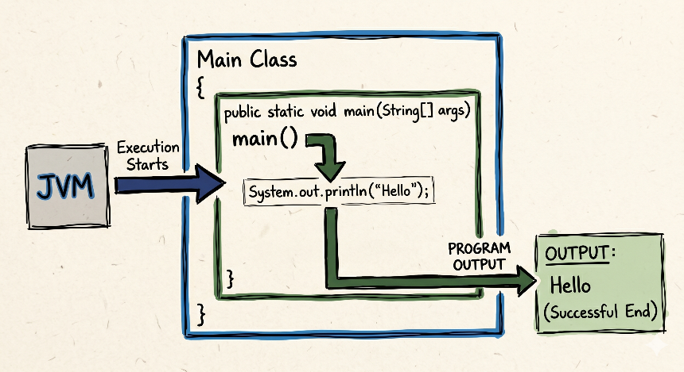

🧩 PATTERN RECOGNITION
👉 Every Java program → must have:
- class
- main()
⚡ CHEATSHEET
Class → container
main() → entry point
PSVM → shortcut

🧠 2. COMPILATION PROCESS
📘 THEORY
Java is platform independent because:
👉 Code is NOT directly executed
👉 It goes through bytecode

🔄 FLOW
.java
↓
javac (compiler)
↓
.class (bytecode)
↓
JVM
↓
Output
// filename: CompilationDemo.java

public class CompilationDemo {
public static void main(String[] args) {
System.out.println("Hello, Platform Independence!");
}
}
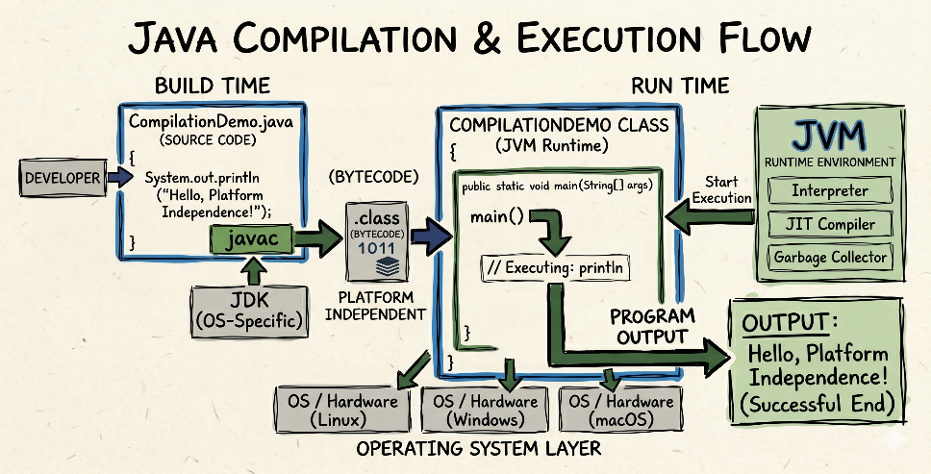

🧠 3. INPUT / OUTPUT

THEORY
- Output = showing data
- Input = taking data
🔄 FLOWCHART
Keyboard
↓
System.in
↓
Scanner
↓
Variable
🎯 DRY RUN
User inputs: 10
→ Scanner reads
→ stored in variable

💻 CODE
Scanner in = new Scanner(System.in);
int a = in.nextInt();

🧩 PATTERN
👉 Keywords:
- “take input”
- “user input”
→ Use Scanner
WHAT IS SCANNER ?
The Scanner class in Java is a part of the java. util package and is used for obtaining input of primitive types like int, double, etc., and strings from the user or a file. It provides various methods to parse and process input, making it versatile for reading different types of data.
Scanner class is present in the java.util package
We can use this class to read input from a user or a file
🟢 When to use Scanner
- Interactive Programs: Use it when you want a human to type answers in the console.
- Simple Input: Best for small, simple tasks like reading a name or a number.
- Learning Java: It is the standard way for beginners to handle input because the code is easy to read.
- Small Files: Good for reading a text file that isn't very large or complex.
- Parsing Strings: Use it if you need to break a single sentence into separate words easily.
🔴 When NOT to use Scanner
- Large Files: Do not use it for very big files (like a database log). It is slow. Use BufferedReader instead.
- Speed-Critical Tasks: If you are doing competitive programming where milliseconds matter, Scanner is too slow.
- Multi-threaded Apps: Scanner is not "thread-safe." If multiple parts of a program use it at once, it can crash.
- Binary Data: Do not use it for images, music, or video files. Use FileInputStream for those.
- GUI Apps: If you are building a window with buttons and text boxes (like a real app), you use "Events," not a Scanner.

import java.util.Scanner; // 1. Tell Java we need the Scanner tool

public class SimpleInterview {
public static void main(String[] args) {

// 2. Create the Scanner "mailbox" to listen to the keyboard
Scanner input = new Scanner(System.in);

// --- SCENARIO: Reading a Sentence ---
System.out.print("Enter your full name: ");
String name = input.nextLine();

// --- SCENARIO: Reading a Whole Number ---
System.out.print("Enter your age: ");
int age = input.nextInt();

// --- SCENARIO: Reading a Decimal Number ---
System.out.print("Enter your height (e.g., 5.9): ");
double height = input.nextDouble();

// --- SCENARIO: The Output ---
System.out.println("\n--- Results ---");
System.out.println("Hello, " + name + "!");
System.out.println("You are " + age + " years old.");
System.out.println("You are " + height + " feet tall.");

// 3. Close the scanner to be a good programmer
input.close();
}
}
⚠️ MISTAKES
- Forgetting import
- Wrong method (next vs nextLine)
CHEATSHEET
Input → Scanner
Output → System.out

System.out.print()
System.out.println()
print → same line
println → new line
nextInt() vs nextLine()
👉 nextLine() takes full line
👉 next() takes word

🧠 4. DATA TYPES
📘 THEORY
Data types define:
👉 What value
👉 How much memory
Stack → variables Variables - a (Assigned)
Heap → actual data Heap – 10 (Value)

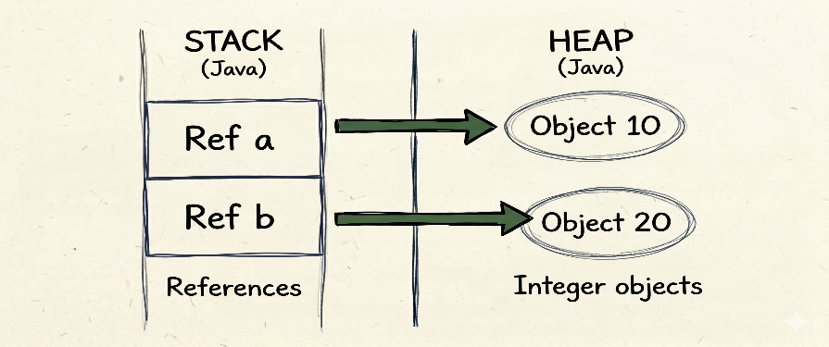

🔄 FLOWCHART
Data Types
↓
Primitive
↓
Int, float ,double ,char ,boolean ,long

int a = 10;
a stores integer
int a = 10;
float b = 20.5f;
🧩 PATTERN
👉 If question says:
- integer → int
- decimal → float/double
⚠️ MISTAKES
- Missing f in float
- Using wrong type
int → numbers
float → decimals
char → character
boolean → true/false

🧠 5. TYPE CONVERSION

Two types:
👉 Automatic → small to big
👉 Casting → big to small CASTING MEANS DATA LOSS
Small → Big → Automatic want output 10.5 but came 10
Big → Small → Casting
auto → safe
casting → risky

int y = (int)10.5;
System.out.println(y);
✅ Output:
10

💡 Why?
10.5 → cast to int → decimal removed → 10
🧠 2. Float vs Casting
float y = 10.5f;
System.out.println(y);
✅ Output:
10.5
💡 Why?
No casting → value remains same
🧠 3. Casting then Storing in Float (Tricky)
float y = (int)10.5;
System.out.println(y);
✅ Output:
10.0
💡 Why?
Step 1: 10.5 → (int) → 10
Step 2: 10 stored in float → 10.0

🧠 6. Type Promotion (VERY IMPORTANT)
byte a = 10;
byte b = 20;
int c = a + b;
System.out.println(c);
✅ Output:
30💡 Why?
byte + byte → promoted to int
🧠 7. Wrong Assignment (Common Error)
byte a = 10;
byte b = 20;
byte c = a + b;
❌ Output:
Compilation Error
💡 Why?
a+b becomes int → cannot store in byte
🧠 8. Mixed Types
int a = 10;
double b = 5.5;
double c = a + b;
System.out.println(c);
✅ Output:
15.5
💡 Why?
int → promoted to double
Result = double

🧠 9. Casting in Expression
int a = (int)(5.5 + 2.3);
System.out.println(a);
✅ Output:
7
💡 Why?
5.5 + 2.3 = 7.8
(int) → 7

🧠 10. Division Trap
int a = 5 / 2;
System.out.println(a);
✅ Output:
2
💡 Why?
int/int → int → decimal removed

🧠 11. Fix Division
double a = 5 / 2.0;
System.out.println(a);
✅ Output:
2.5
💡 Why?
int → promoted to double

🧠 12. Char + Int
char ch = 'A';
int x = ch + 1;
System.out.println(x);
✅ Output:
66
💡 Why?
'A' = 65
65 + 1 = 66

🧠 13. Char Output
System.out.println('A' + 1);
✅ Output:
66

🧠 14. Cast back to char
System.out.println((char)('A' + 1));
✅ Output:
B

🔥 FINAL CHEATSHEET
Casting → cuts decimal
Promotion → smaller → int
String + anything → string
int/int → int
char → ASCII value
🧠 What is byte in Java?
👉 byte is a primitive data type used to store small integer values
byte a = 10;
👉 It stores:
- Whole numbers (no decimal)
- Very small range

Range (IMPORTANT 🔥)
-128 to 127
👉 Why?
Because:
- byte = 1 byte = 8 bits
- 2⁸ = 256 values
- Half for negative, half for positive
Think of byte like:
- A small box
- Can only hold small numbers
If you try bigger number → overflow/error
When to use byte?
👉 Rare in DSA
👉 Used when:
- Memory optimization needed
- Large arrays (advanced cases)
byte:
range → -128 to 127
size → 1 byte
type → integer
rule: byte + byte → int

Mentor Tip
👉 In DSA:
- Use int mostly
- Don’t overuse byte
🧠 6. CONTROL FLOW
📘 THEORY
Controls execution:
- if → condition
- loops → repetition
🔄 FLOWCHART
Condition?
/ \
Yes No
↓ ↓
Execute Skip
🎯 DRY RUN
if(5>3) → true → execute

💻 CODE
if(a>b){
System.out.println(a);
}

🧩 PATTERN
👉 “decision” → if
👉 “repeat” → loop

⚠️ MISTAKES
- Wrong condition
- infinite loop

⚡ CHEATSHEET
if → decision
for → known loop
while → unknown loop

